- Purpose
  - The purpose of this document is to describe the procedure for assembling the Solution Tank on the Genesys Mid-Sized Machine.
- Scope
  - This SOP applies to all equipment assembly team members. The process applies to the following machine ID’s:
EP50303EQS0600BE1200 – Solution Tank Assembly
- Responsibilities
  - The operations manager/supervisor is responsible for enforcing this SOP.
- Materials
  - The proper materials needed for this process are listed on the machine work order.
- Definitions

- Procedure
  - Start with a solution tank (E28563). Flip it over so that the bottom is exposed.
  - Use a 1 ¾” diameter hole saw to cut out the rear fill port. There is a drill point in the tank to mark the location. Try as best as possible to keep as many shavings out of the tank as possible.

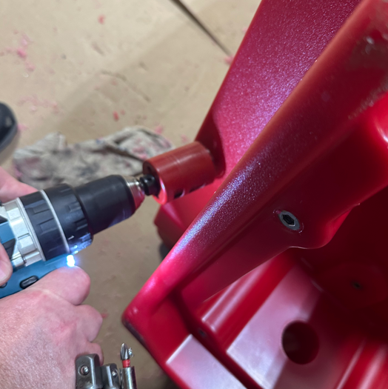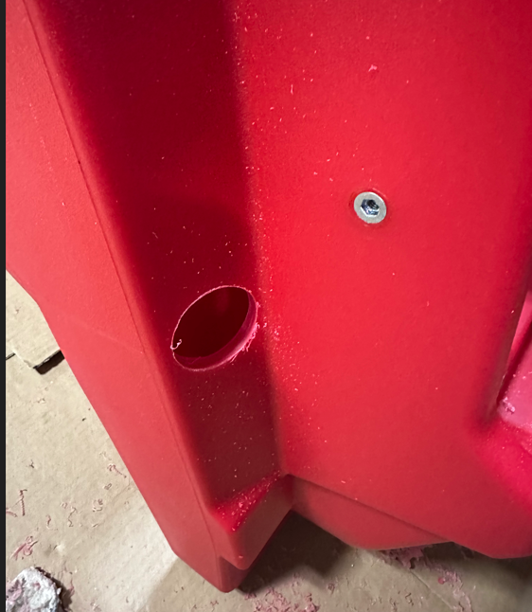

  - Use either a 29/32” or 59/64” drill bit to drill out the top end of where the sight tube will go along. Then drill on the bottom of the tank where the solution port is. Take care to ensure the hole is straight and is not allowed to “oval”. There is a drill point in the correct locations. Try as best as possible to keep as many shavings out of the tank as possible.

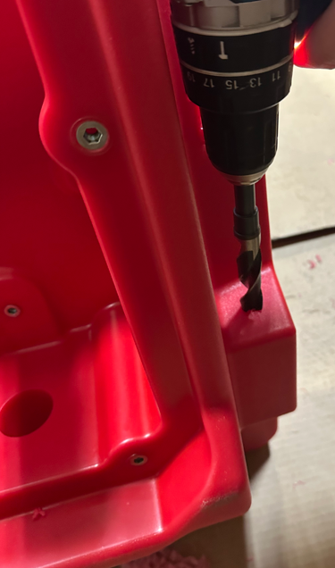
  - Use a ¾” NPT tap to tap out the holes in each of the two locations. Try to keep the shavings out of the tank. Ensure the tap is aligned properly and not angled.

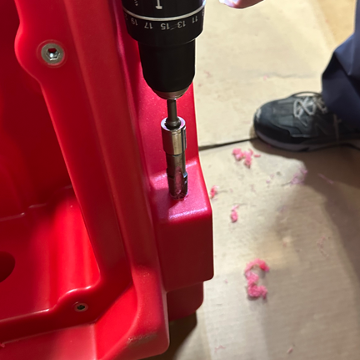

  - Take the tank to the rinsing station and rinse it thoroughly to flush out any remaining shavings that got into the tank. Allow the tank to drain completely when finished.

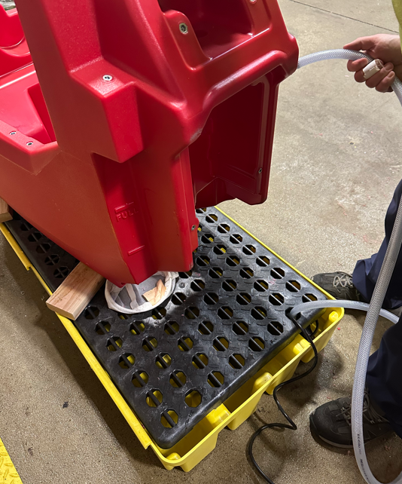

  - Thread a barbed elbow into the bottom of the tank (E28750). Use blue sealant on both the tank threads and the fitting. Note the orientation. Ensure that it is properly seated.
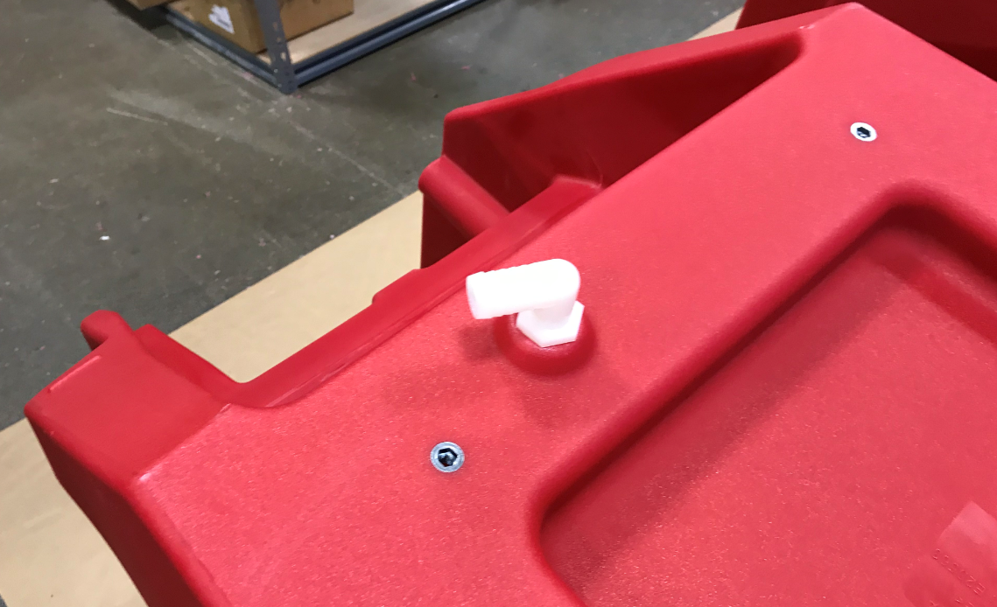
  - Thread a barbed fitting (E29305) for the top of the sight tube into place. Use a piece of sandpaper to round off the corners of the barb so the hose can easily be installed and removed.
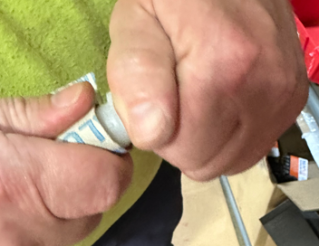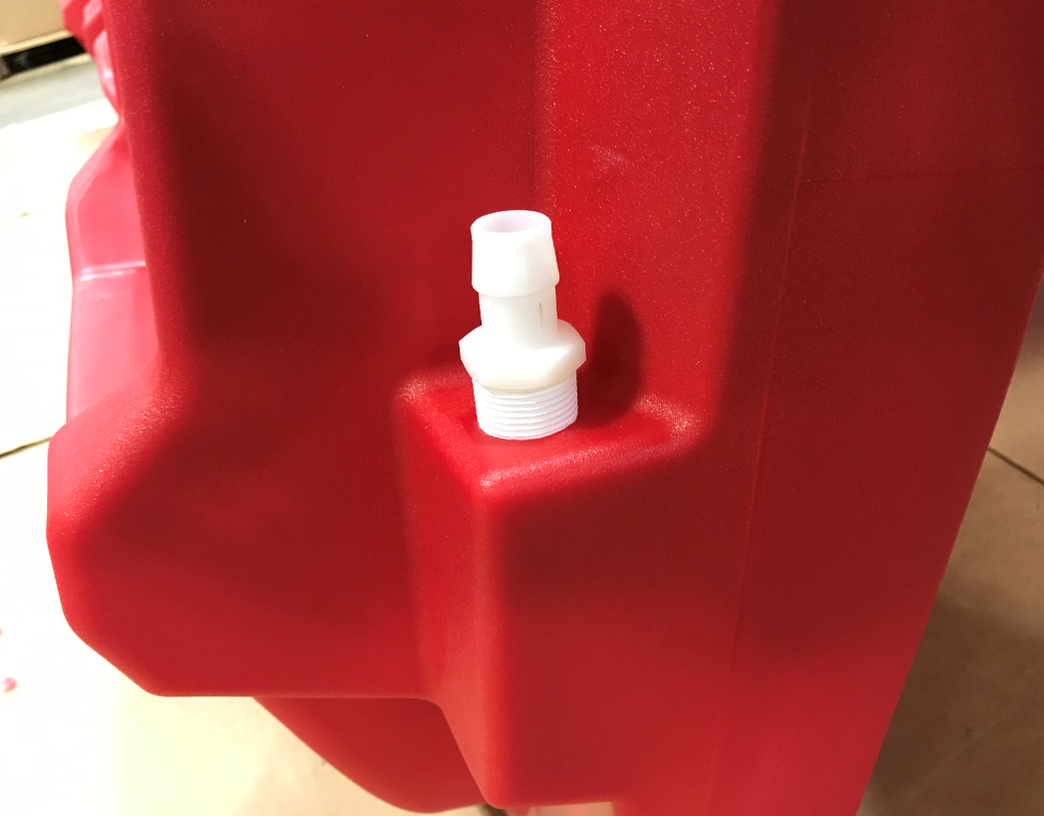
  - Install the hanger bolts for the front cover. This uses 4 spacers (E29579), 4 bolts (E81089), and 4 washers (E29388). The washer goes under the bolt head.
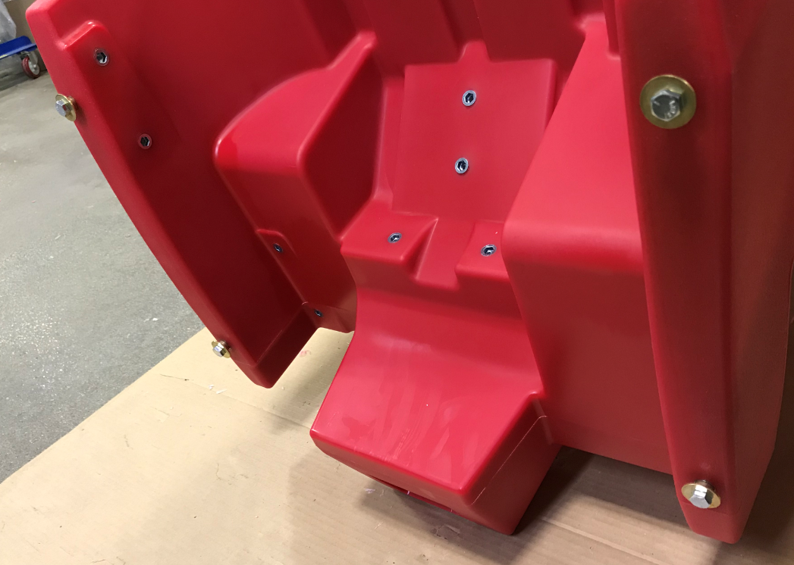
  - Attach the tank it to a lower frame using 4 bolts (E81089) and 4 flat washers (E29388). Tighten to 8.5ft-lbs. Mark the bolt orientation using a paint marker.
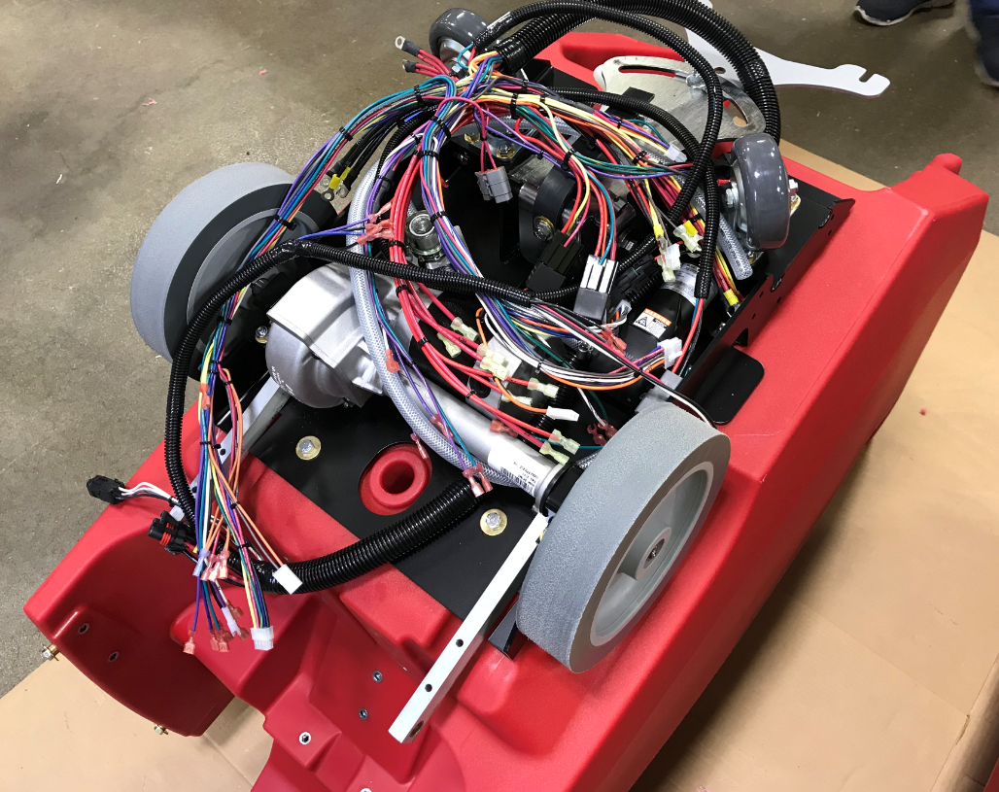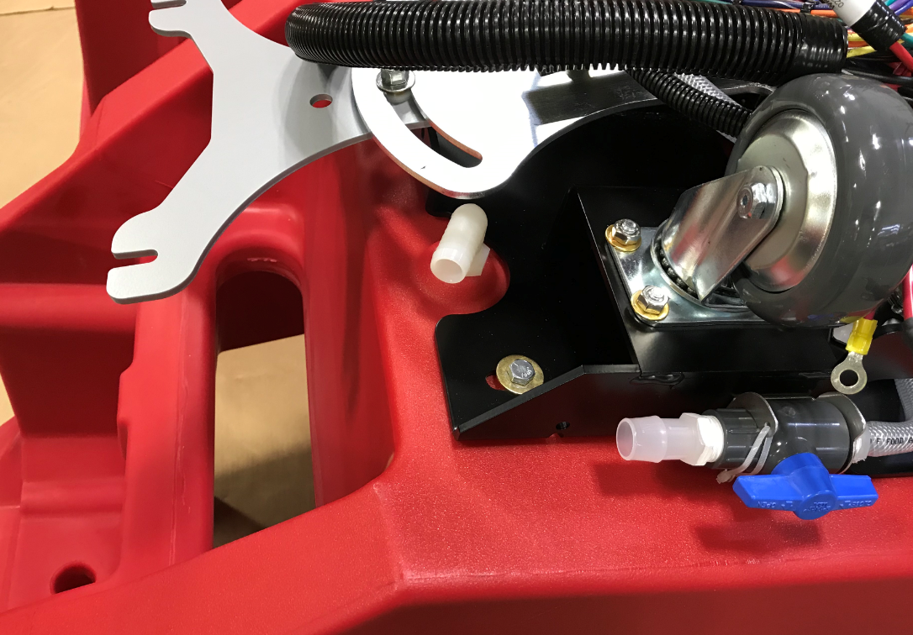
  - Cut a 26” piece of ¾” tubing (E28922) for the sight hose. Press the outlet side of a t-fitting (E28749) onto an end of the tube. Attach it with a worm clamp (E28766). Cut a 5” piece of the same tubing and press it onto the inlet port of the t-fitting. Attach it with a worm clamp (E28766). Cut a 4 1/8” piece of tubing and install it onto the other outlet port of the t-fitting. Attach it with another worm clamp (E28766).
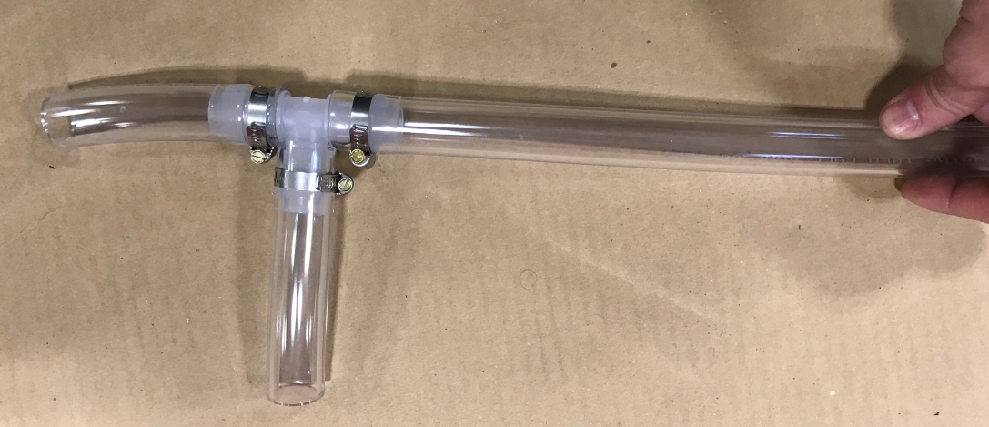
4 1/8”
26”
5”
  - Install the tubing assembly onto the machine. The end of the 26” piece goes up to the top of the sight tube. The 5” piece connects to the elbow coming out of the bottom of the tank. The other piece connects to the ball valve on the frame. Both pieces are attached in place using worm clamps (E28766).
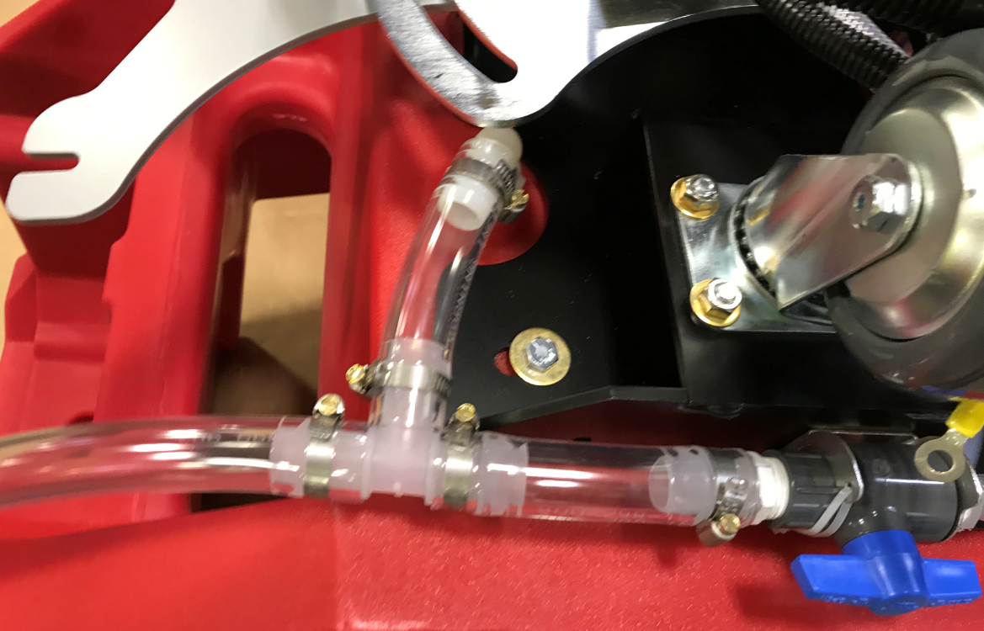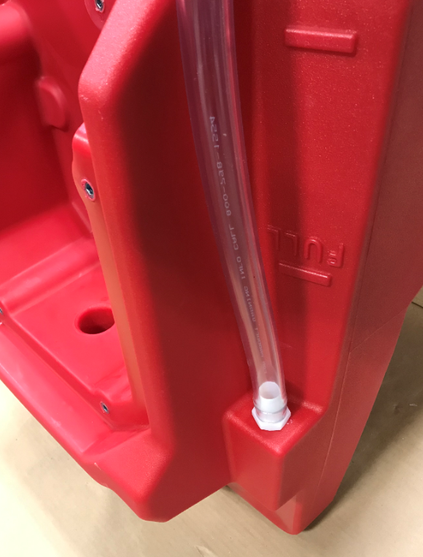

  - Tie the frame arms as shown so they don’t drag on the floor.

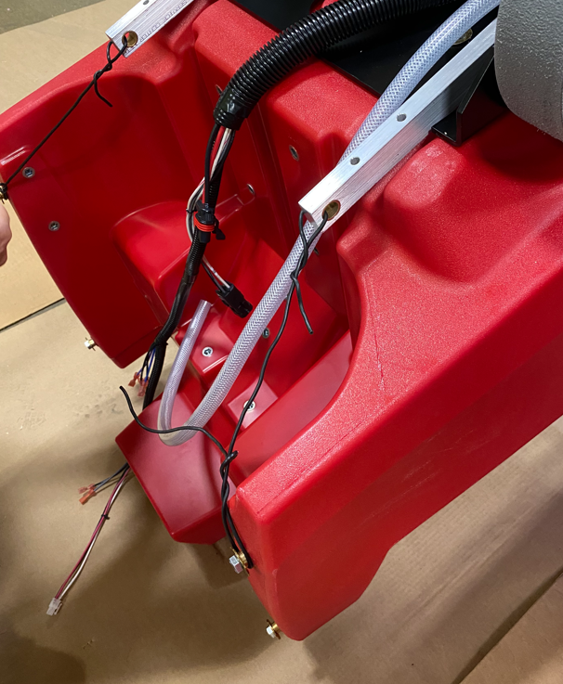

  - Flip the tank/frame assembly over onto the wheels.
  - Feed the wire harness up through the cutout shown and lay it inside of the battery compartment.

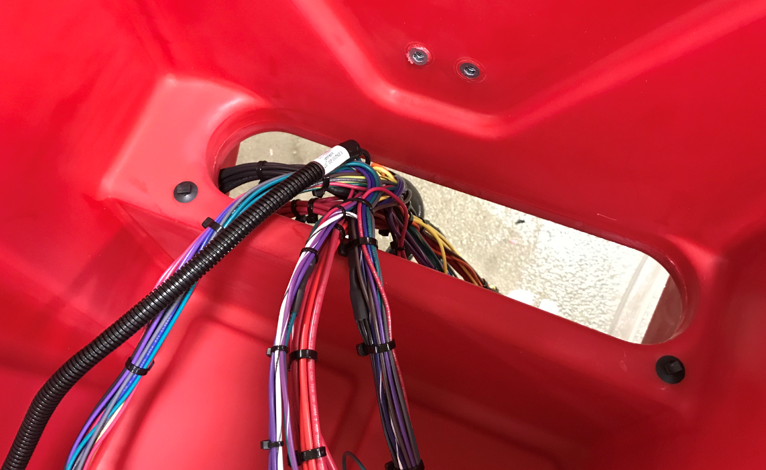

  - Take the squeegee bracket and use the main trunk of the wire harness to hold it up off of the floor until it gets attached.

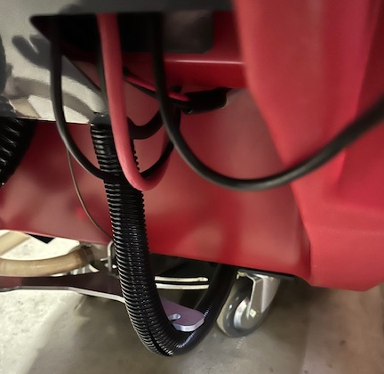

  - Press a wire tie push mount (E28621) into the two location inside of the solution tank.
  - Stick 2 handle seals (E28823) into the location where the handle will mount. They just get stacked.
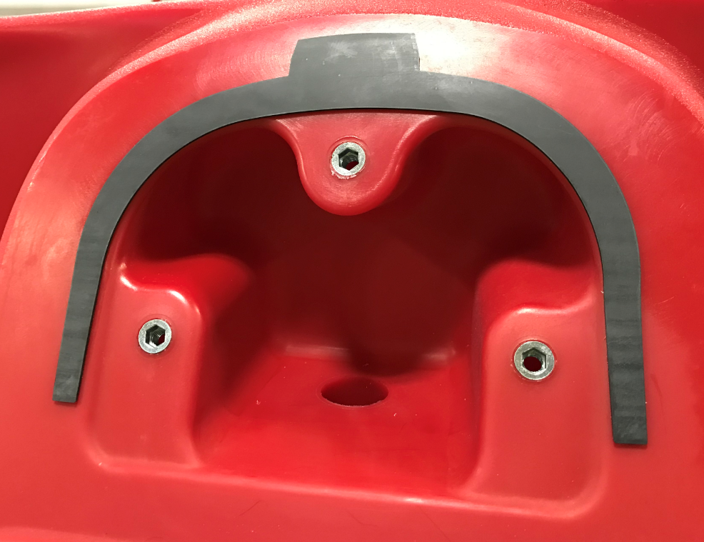
  - Install the squeegee hang bracket (E28707). Use a hex bolt (E81089), a wave washer (28765), and a flat washer (E29403). Use some Blue Loctite on the threads. The washers go behind the bracket. Do not overtighten as the bracket needs to pivot up and down.
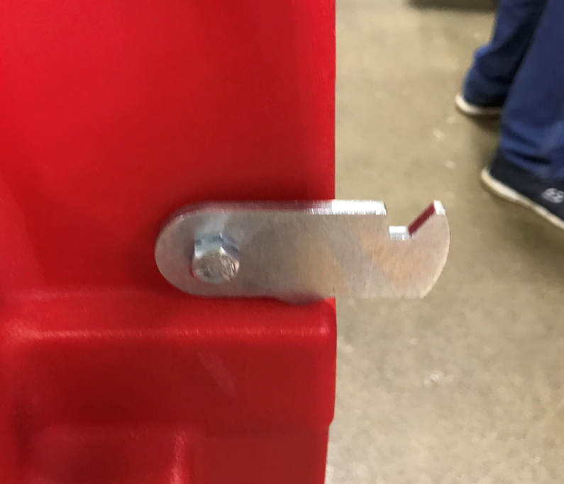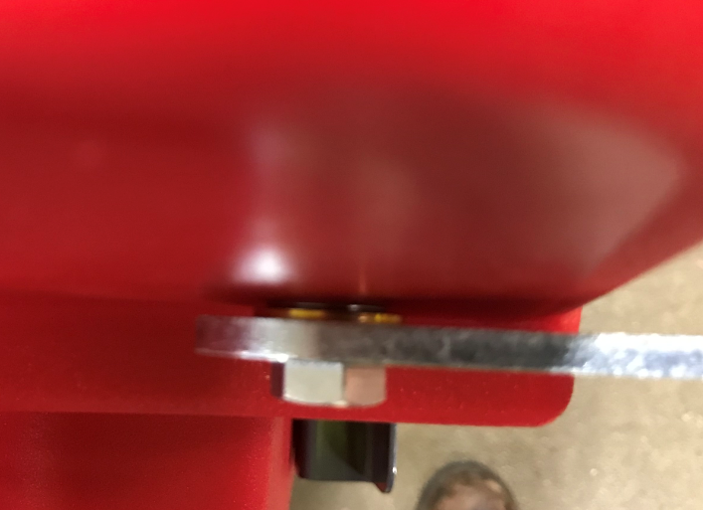
  - Attach a recovery tank hose bracket (E28712) using a button head screw (E28648).
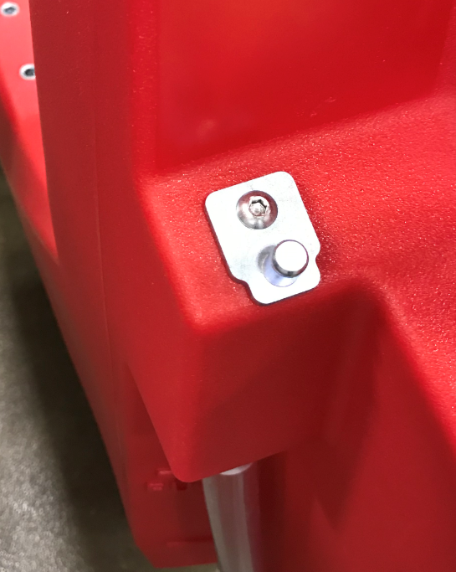
  - Mount the charger cord wrap bracket (E28737) using 2 bolts (E28648).
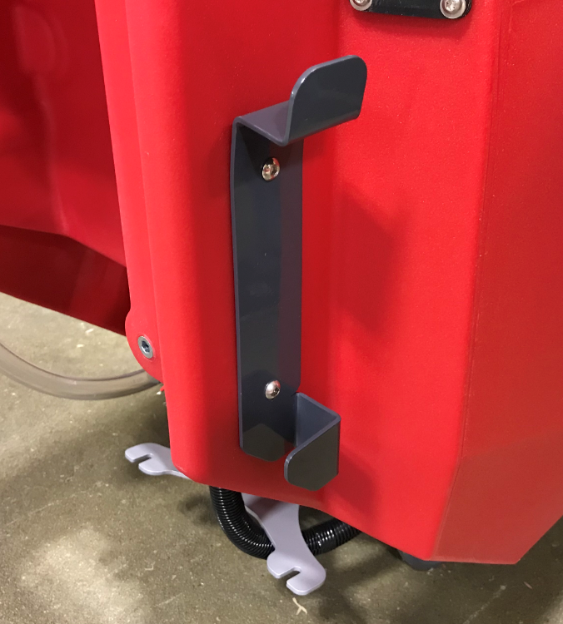
  - Take a cable guide bracket (E28714) and put a cable guide (E28715) through the hole. Attach them with a snap ring (E28722).
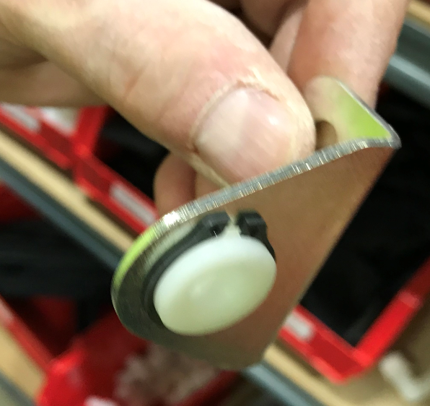
  - Attach the bracket to the tank using 2 hex bolts (E28648).
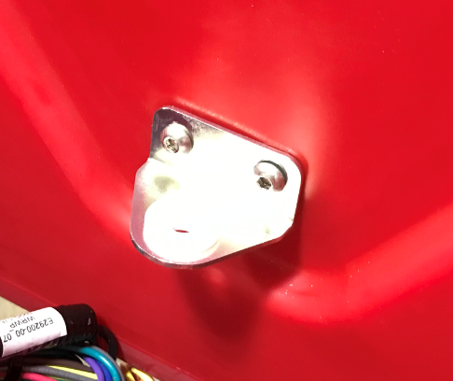
  - Feed the handle of the squeegee lift lever (E28909) through a squeegee lever guide (E28756). Slide a squeegee lever grip (E28721) into place.
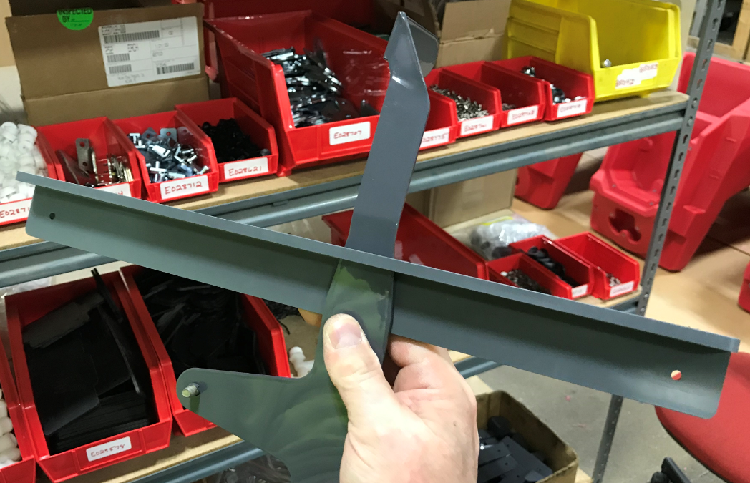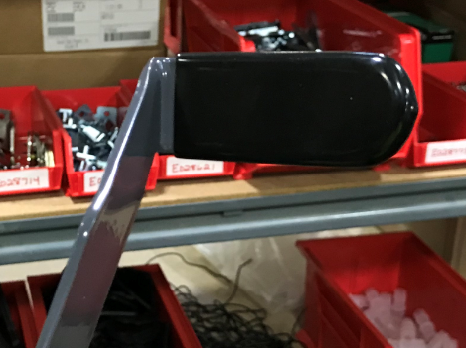
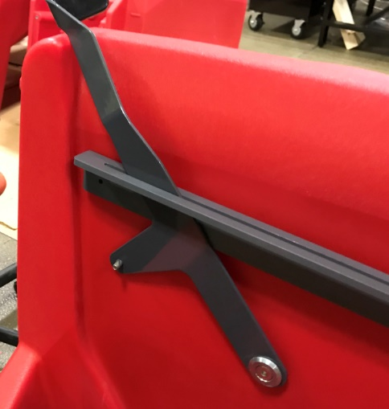
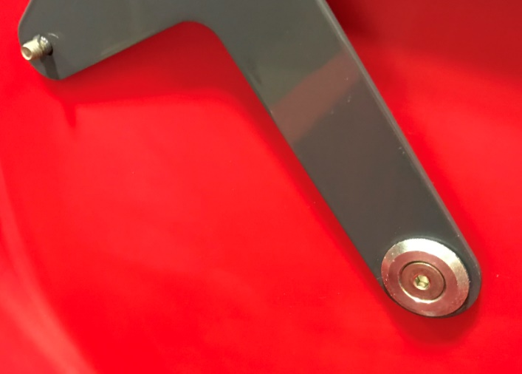
  - Attach the lever to the solution tank using a nylon washer (E28719) (Between the lever and the tank), a squeegee lever bushing (E28718), and a flat head screw containing Blue Loctite. (E28763). Ensure that the nylon washer stays over the end of the bushing during tightening. If it comes off it will get pinched against the tank and not work properly.

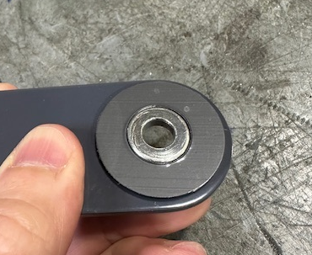

  - Attach the squeegee lever guide in place by first drilling pilot holes with the #29 drill bit provided. Ensure it is level. Position it so that there is about ½” clearance between the arm and the bottom of the bracket. Use 2 screws (E28761) and 2 washers (E28775). Ensure the lever can pivot easily.
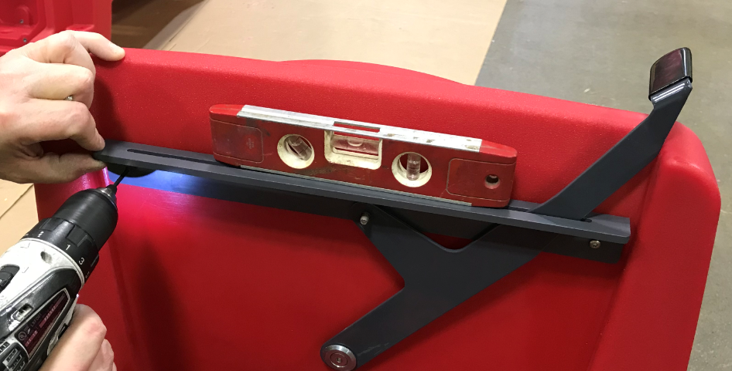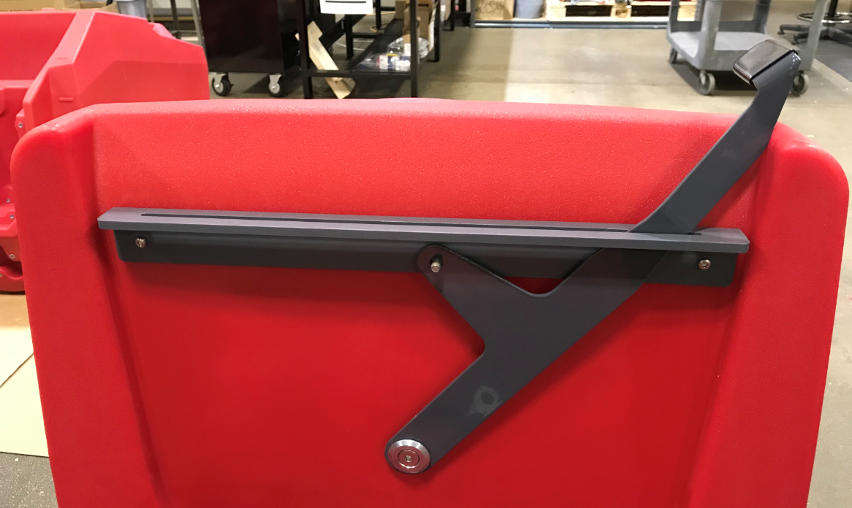
½” Clearance
  - Attach a front fill cover (E28825). Position it into the proper location and drill 2 pilot holes using the supplied #29 drill bit. Attach the cover using 2 screws (E28761) and 2 washers (E28775). Do not over tighten.
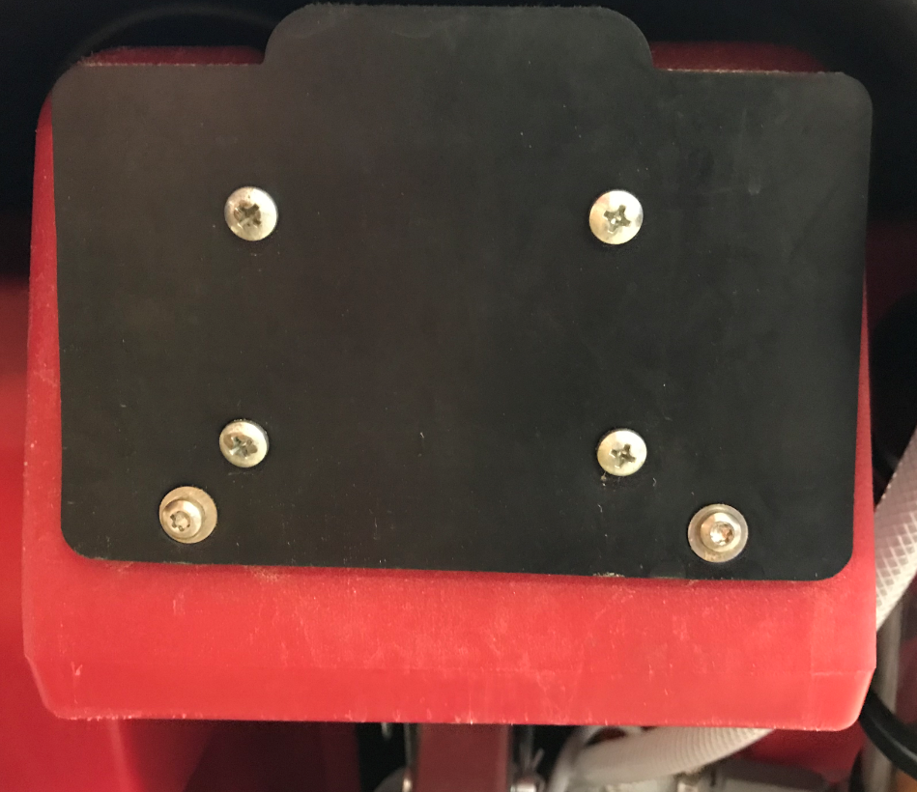
  - Attach a rear refill port cover (E28837) by positioning it into the proper location and drilling a pilot hole using the supplied #29 drill bit. Attach the cover using a screw (E28761) and a washer (E28775). Do not overtighten.

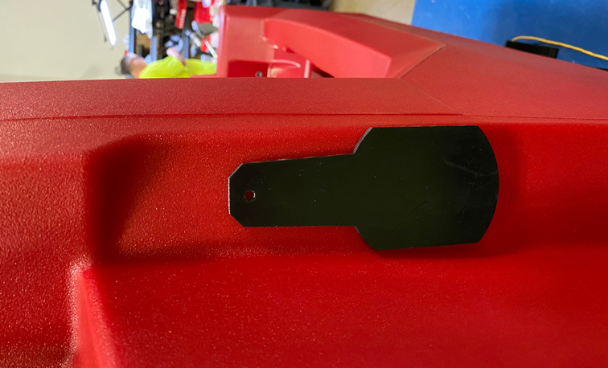

  - Attach the eyelet end of a squeegee lift cable (E28759) onto the threaded stud using a nylock nut (E29565). Ensure it can still pivot.
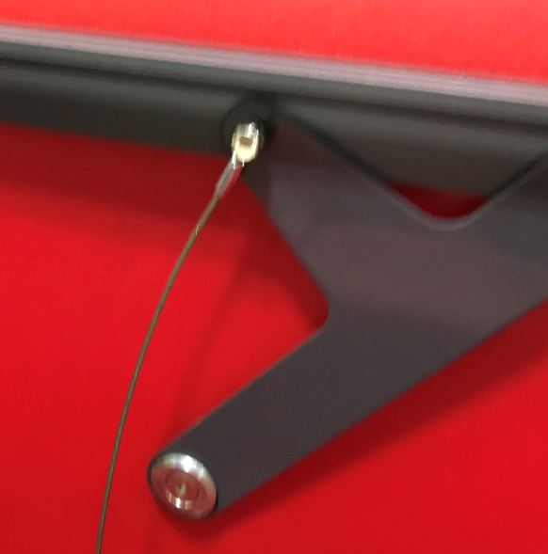
  - Feed the stud end of the lift cable through the cable guide bracket.
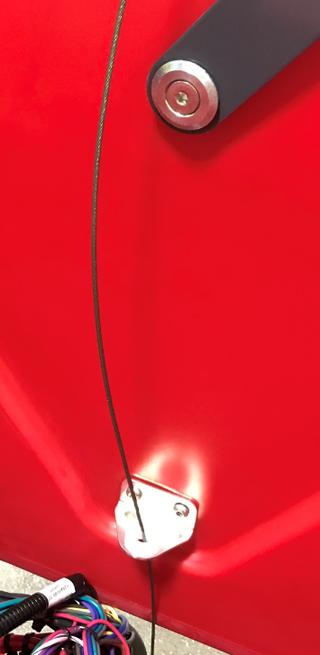

- References (optional section as needed)

- Training Guide

Functional Training Groups Requiring Training
Equipment Assembly Group

- SOP Change Control

Date of Change | Reason for Change
Rev 01 | This is the first version of the S.O.P. hence there are no revisions to this document.
Rev 02 - 8/13/2021 | Added QC Check, Bolt Torque notes, and Blue Loctite notes
Rev 03 - 3/31/2025 | Updated process
Rev 04 – 1/20/2026 | Moved battery installation to the final assembly SOP

Approvals

Submitter/Author Approval:__________________________________ Date:______________________

Management Approval:______________________________________ Date:______________________

QAU Approval:_____________________________________________ Date:______________________

